Science Week 9 Animals Homes
Activity 1- Nature Walk- Go for walk around your yard/neighborhood and look for signs of different animal homes. Makes some notes and draw a sketch describing what you saw. You may find footprints or scat … to indicate an animal lives close by.
Draw and fill in a chart like the one below OR take a photo of the animal home (***PLEASE BE RESPECTFUL WE DO NOT WANT TO CAUSE STRESS OR HARM TO ANIMALS OR THEIR HOMES)

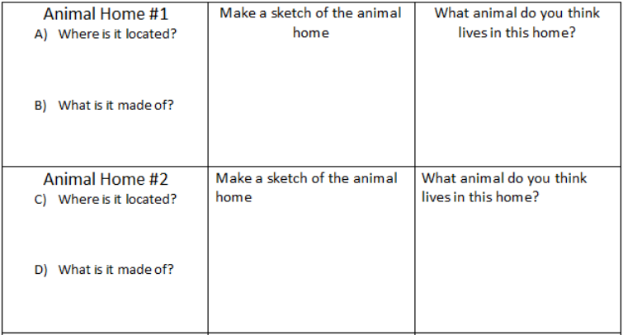
Activity 2- One of the most familiar animal homes in most of our yards are birds’ nests. Have you ever wondered, WHY DO MOST BIRDS LAY THEIR EGGS IN THE SPRING?
- Part A) Have a discussion with another family member about why they think why Spring is the best season for birds to lay their eggs.
- Part B) Click on the Mystery Science link and watch how scientists describe “Why they Believe Birds Lay Eggs in The Spring” https://mysteryscience.com/mini-lessons/birds-spring?loc=mini-lesson-button#slide-id-8400

Activity 3- Check out the “Bonus Box”, this week features “Top 5 Amazing Bird Nests,” which shows off unusual nests made of mud, sewn leaves, and more!

Activity 4- Design & Build your own “DREAM NEST”
Can you build a nest that will hold an egg? Give it a try. If you can go outside, gather twigs, leaves and grass to build with- just like the birds do! If you can’t go out, use torn paper, rolled up paper and string. You can’t use glue or tape! When your done building, test your nest with something round- like a marble, or even a real egg.
Post a picture😊

